Additional Material 3: Investigation forms
Figure A.1: Standard form for investigating garbage codes deaths in hospitals.
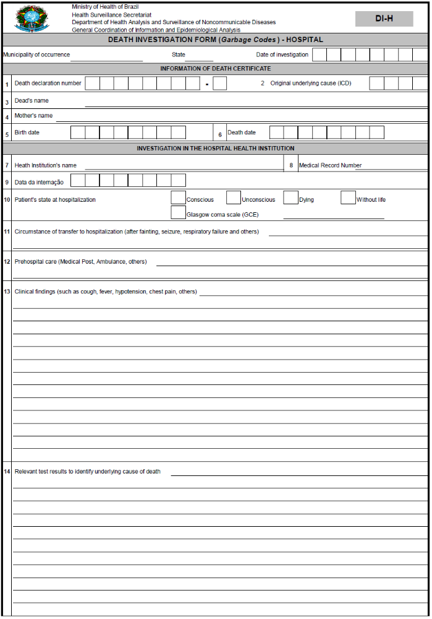

Figure A.1: Standard form for investigating garbage codes deaths in hospitals (continued...)
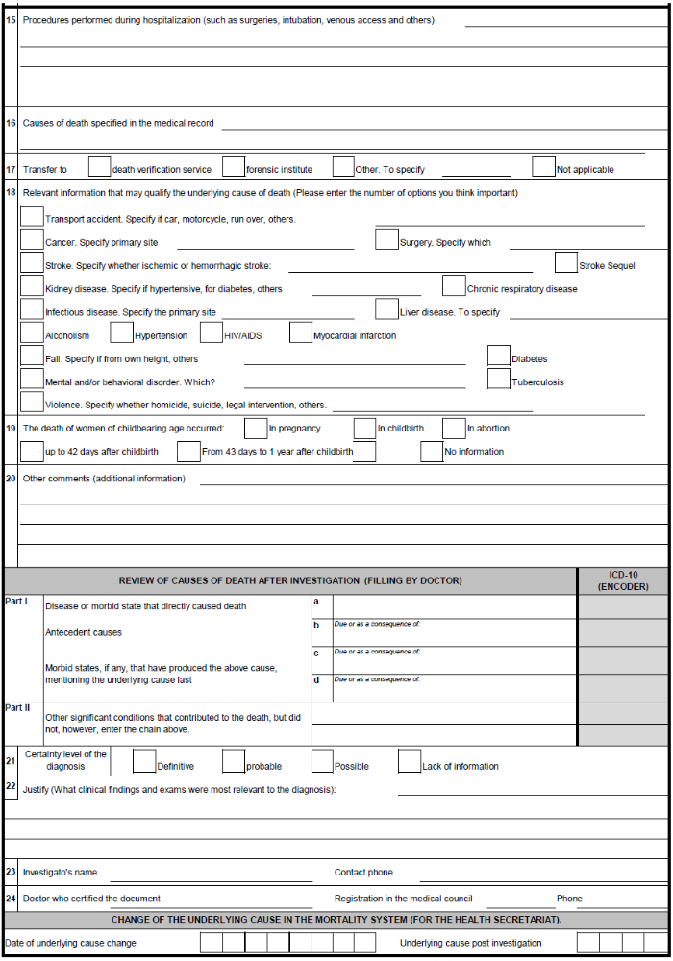

Figure A.2: Form for the investigation of deaths from external causes (IDEC), field tested version 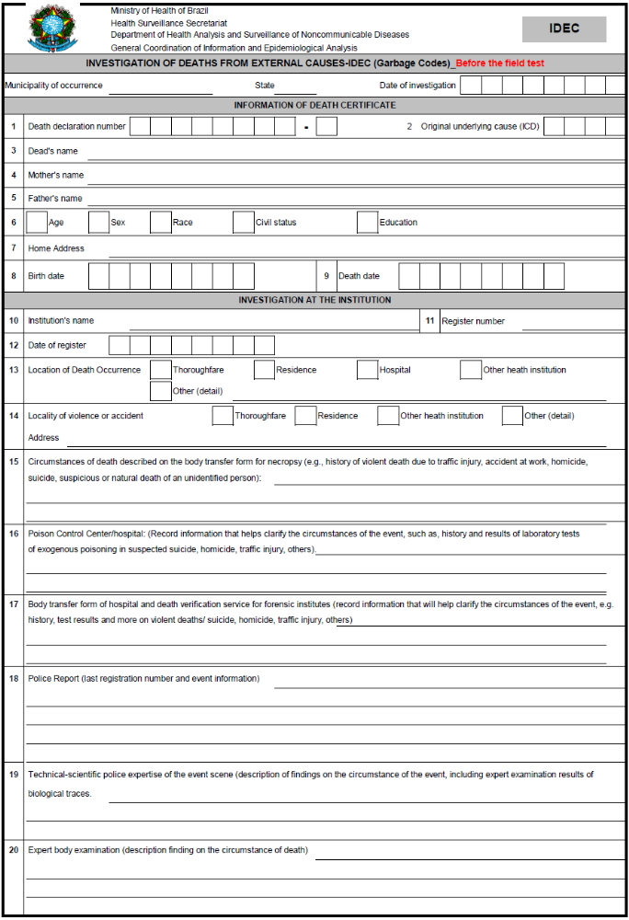
Figure A.2: Form for the investigation of deaths from external causes (IDEC), field tested version (continued...)
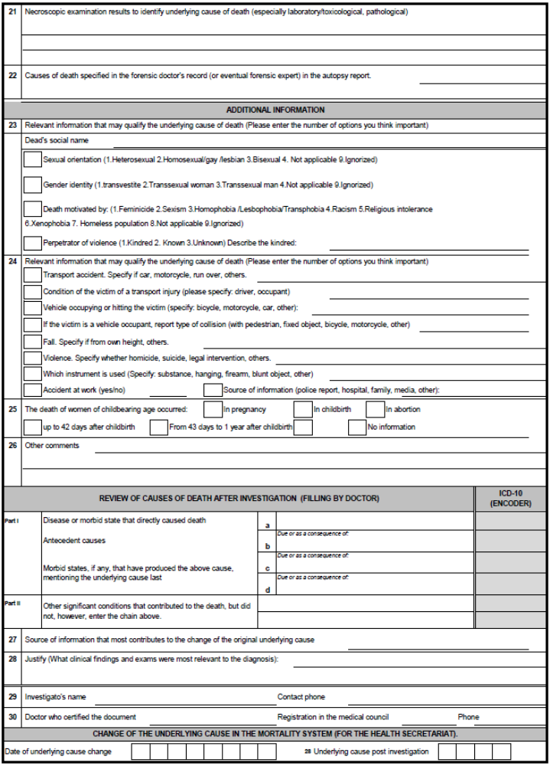

Figure A.3: Form for the investigation of deaths from external causes (IDEC), modified version after field testing
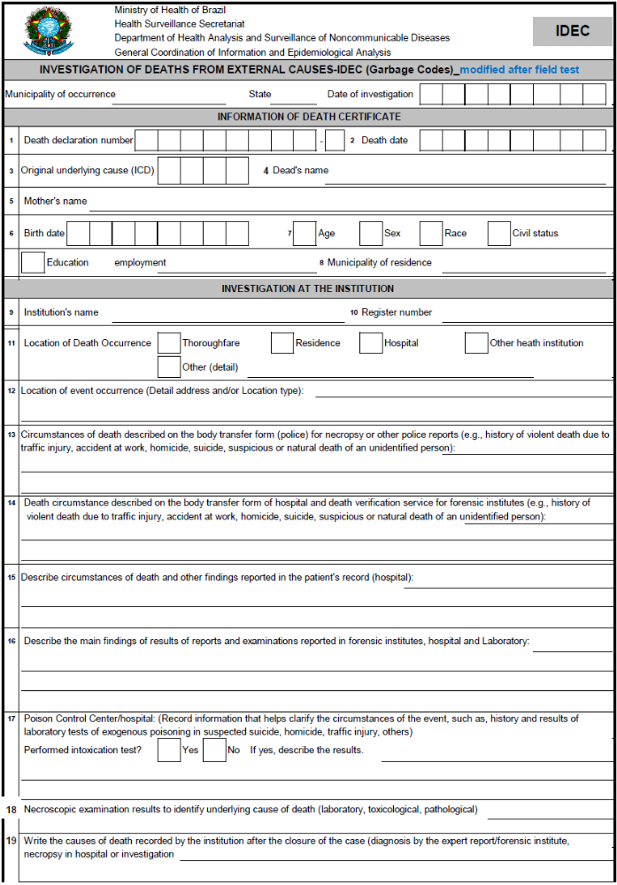

Figure 4: Form for the investigation of deaths from external causes (IDEC), modified version after field testing (continued...)
